Evaluation Analysis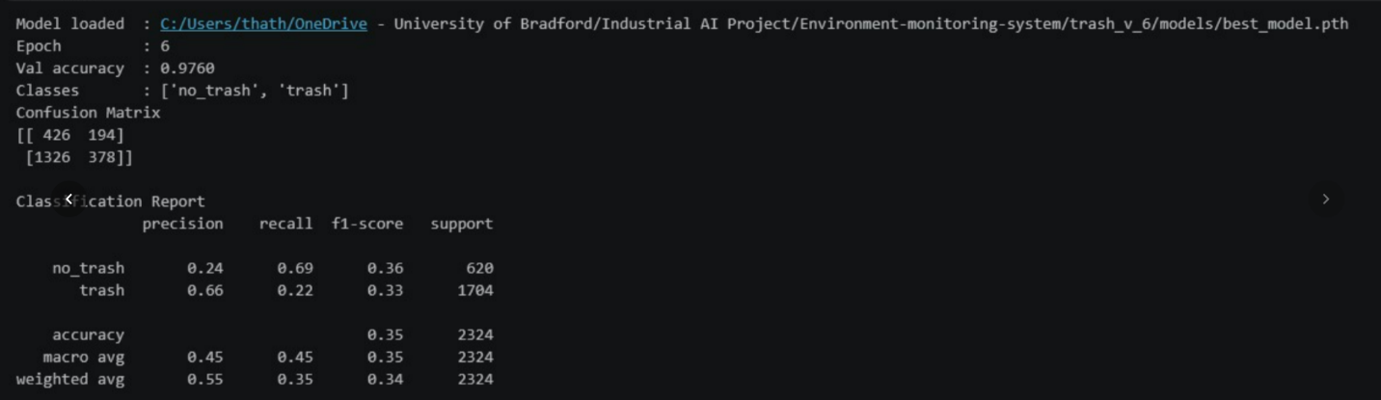
The waste classification model (MobileNetV3) was evaluated using a dataset composed of the TACO dataset for the trash class, along with additional images of bags and visually similar objects to represent challenging non-trash scenarios.
Overall Performance
- Validation Accuracy: 97.6%
- Test Accuracy: 35%
There is a significant gap between validation and test performance, indicating that the model does not generalise well to unseen data.
Class-wise Performance
Trash Class
- Precision: 0.66
- Recall: 0.22
- F1-score: 0.33
Interpretation:
- The model is moderately precise when predicting trash (fewer false positives)
- But very poor recall means:
  - It misses a large number of actual trash instances
  - Many dumping events would go undetected in practice
No Trash Class
- Precision: 0.24
- Recall: 0.69
- F1-score: 0.36
Interpretation:
- The model detects no-trash reasonably well (higher recall)
- But very low precision means:
  - It frequently misclassifies trash as non-trash

Confusion Matrix Insights
[[426 194]
[1326 378]]
- False Negatives (1326) are extremely high
The model fails to detect many trash instances
- False Positives (194) are relatively lower
The model is conservative when predicting trash
This confirms:
The model is biased towards predicting “no trash”
Key Issues Identified
1. Poor Generalisation
- High validation accuracy vs low test accuracy suggests:
  - Overfitting
  - Dataset mismatch between training and testing

2. Class Imbalance
- Support:
- Trash: 1704
- No trash: 620
Despite more trash samples, the model still performs poorly on recall, suggesting:
- imbalance in feature representation, not just quantity

3. Visual Ambiguity
Using:
- bags
- objects that resemble trash
introduces hard negative examples, which:
- confuse the classifier
- reduce recall for actual trash
This reflects real-world complexity, but also exposes model limitations

4. Low Recall for Target Class (Critical)
For this application:
Detecting trash is more important than avoiding false alarms
But:
- Recall (trash) = 0.22
This is a major limitation for deployment:
- The system would miss most illegal dumping events
Implications for the System
- The classifier alone is not reliable enough for real-world deployment
- However, within the full pipeline:
  - motion detection
  - object tracking
  - temporal filtering
These components may compensate for classifier weaknesses
Recommendations
1. Improve Dataset Quality
- Add more diverse real-world trash images
- Reduce ambiguity in “non-trash” samples
2. Use Class Balancing Techniques
- Weighted loss function
- Oversampling / augmentation
3. Upgrade Model
- Consider object detection models (e.g., YOLO)
- Better suited for real-world scenes
4. Threshold Tuning
- Adjust decision threshold to improve recall
- Accept slightly more false positives
Conclusion
While the model achieves high validation accuracy, its performance on unseen data is limited, particularly in detecting trash instances. The low recall highlights a key challenge in distinguishing visually similar objects in real-world environments.
However, the classifier still provides a foundational component within the broader system, where additional modules can enhance overall detection performance.

